CUB SCOUT

PACK [PACK NUMBER]

[Name of Charter Organization]

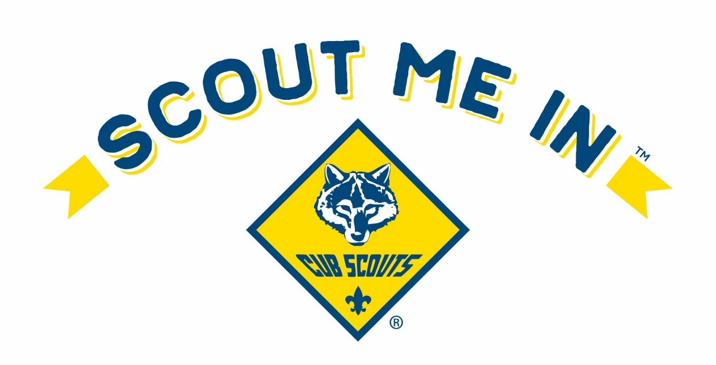

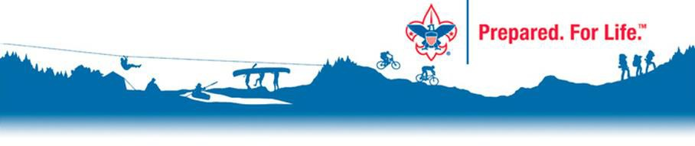
Parent Information Packet [YEAR

]

General Information

History of Scouting
Boy Scouts of America (BSA) was founded in 1910. Since then, more than 130 million Americans have been participants in BSA programs at some time. Today, over 1 million young men and women are involved in Scouting, and over 460,000 adult volunteers. In 2024 Boy Scouts of America was rebranded to Scouting America. Scouting America has the mission to prepare young people to make ethical and moral choices over their lifetimes by instilling in them the values of the Scout Oath and Law.
Cub Scouts was founded in the United Kingdom in 1916, coming to the Boy Scouts of America as several experiments in 1918, with the first official Pack being chartered in 1930. Today, it is a family scouting program for children in kindergarten through fifth grade.

Basic Organization

Cub Scouting is a fun way to spend time with your child and the whole family. The fun has a purpose: That is, to help reinforce the positive values you want your child to develop – character, leadership, personal fitness, and citizenship. These values are presented in a fun and engaging method along with experiencing the outdoors, learning about personal safety, and discovering your family traditions.

Cub Scout-aged children benefit developmentally from belonging to a small group of peers, Your child will be a part of a den, a small group of Cub Scouts in the same grade. Through this sense of belonging, children build self-esteem and learn to get along with others. An Adult Volunteer leads the den, called a Den Leader; an Assistant Den Leader sometimes assists the Den Leader.

We know your child did not join Cub Scouting for character building. Youth join because it is fun. Your child will learn great lessons, but they will be far too busy having fun to notice.
Cub Scout leaders are all volunteers. Adult leaders are mainly there to provide a safe and nurturing environment for Scouts and their activities. The Pack Committee is the governing body and provides leadership to the Cubmaster and Assistant Cubmasters who provide leadership and support to the Den Leaders, who interact with the Scouts regularly. Various other volunteer positions are also needed, such as Camping Chair, Secretary/Communications Chair, Fundraising Chair, Scouting for Food Chair, and Treasurer, among others. These are all volunteer positions filled by parents of the youth involved. Following BSA’s Youth Protection Training, there are always at least two registered adults present for every activity with youth involvement. Pack [NUMBER] is chartered to [CHARTER ORGIZATION NAME and LOCATION].

Advancement
Recognition is important to everyone. The advancement plan provides fun for the Scouts, gives them a sense of personal achievement as they earn badges, and strengthens family understanding as adult family members and their den leader work with them on advancement projects.

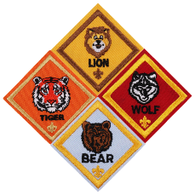
Cub Scout activities are centered around earning badges that are specific to each school grade level. This badge represents a rank. Advancement refers to the progress a Cub Scout makes toward their badge of rank. All the activities for each rank are in the Cub Scout handbooks.

Adventures are based on different topics such as hiking, nature, science, citizenship, first aid, sports, and more, adventures are earned as a Cub Scout advances towards their badge of rank. Once an adventure is completed, a Cub Scout receives recognition in the form of an adventure loop or adventure pin.

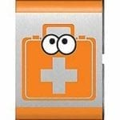

Kindergarten through third grade; Lions, Tigers, Wolves, and Bears earn metal adventure loops. These are designed to slide onto a Cub Scout’s belt.

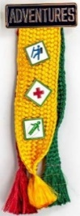

Fourth and Fifth-grade, Webelos and Arrow of Light earn metal adventure pins. These pins are placed on the Adventure Colors.
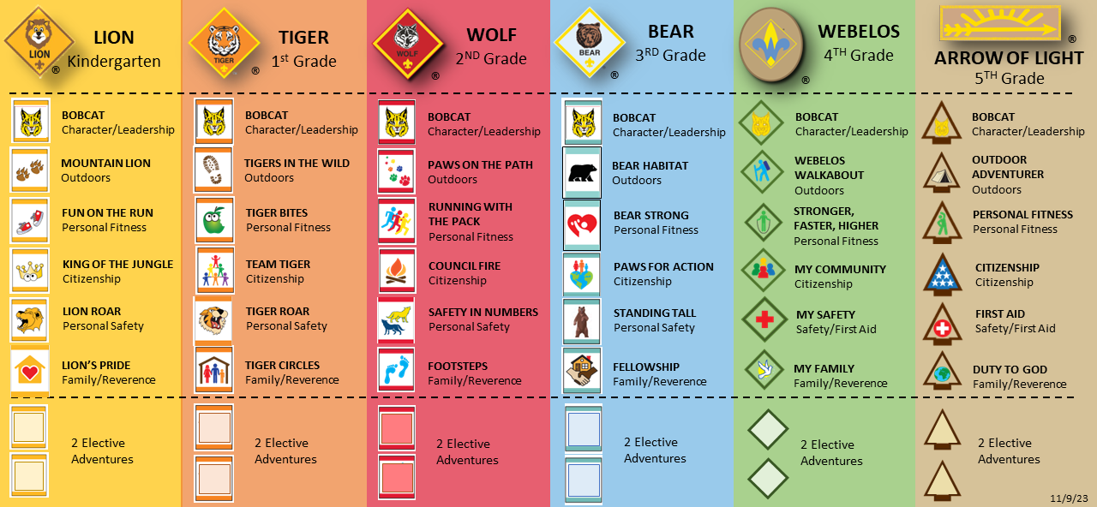

Meetings
[Meeting Location]
Pack [NUMBER] meets on [DAY OF WEEK} nights from [START TIME] to [END TIME] in [LOCATION OF MEETING], unless we have an off-site event.
At Den meetings, Cub Scouts make new friends, play purposeful games, and learn new things while working towards advancement goals.

The Lions (Kindergarten) and Tiger (First Grade) Dens
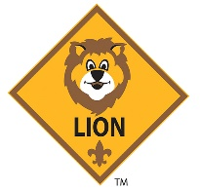
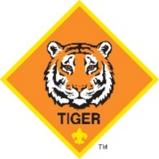
When kindergartners or first graders join the Cub Scouts, they do so with an adult partner, usually a parent or guardian. A Lion or Tiger den should have no more than eight Cub Scouts and their adult partners. An adult, typically one of the parents, is chosen to be the den leader and is responsible for organizing the meetings. Each adult partner takes turns assisting or hosting meetings and activities with the den leader. This shared leadership model ensures that the den leader has the necessary support to provide a quality program.

Wolf (2nd Grade), Bear (3rd Grade), and Webelos (4th Grade) Dens

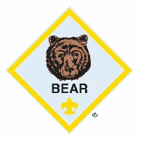
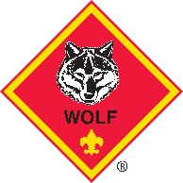
At this age, children are becoming more independent, and the activities are tailored to meet their developmental needs. An ideal Wolf (second grade), Bear (third grade), or Webelos (fourth grade) den consists of no more than eight Cub Scouts, a den leader, an assistant den leader (typically parents of some of the den members), and often a den chief (an older Scout who assists the den leader).

The Arrow of Light Scout Den (5th Grade)

The Arrow of Light den is focused on preparing to join Scouts BSA. Arrow of Light Scouts move to the next level of Scouting, Scouts BSA

Pack Meetings
The Cub Scout Pack Meeting comprises all the dens in Pack [NUMBER], led by the Cubmaster. There are games, skits, songs, ceremonies, and presentations of achievements and badges that Cub Scouts earned during that month.

The pack, including families, also participates in other special events throughout the year, including:

Pinewood Derby® – You can build and race a model car with your child

Blue and Gold Banquet – Cub Scouting’s birthday party – for all pack members and their families – takes place in February.

Camping – Overnight and day camp opportunities introduce your family to the camping experience.

Service Projects – Our Packs might participate in food drives, like Scouting For Food, or conservation projects, or other community activities.

Miss a meeting?
If your Scout misses a meeting, it's not a big deal. Most things covered in a meeting can be made up later. We understand that with sports programs, you might miss a few meetings. Just get in touch with your Den Leader, and they can help you plan how to catch up on what was missed. While attending as many meetings as possible will make for a better experience and allow your Scout to have fun while progressing through their ranks, we know that youth (and parents) have a lot going on!

Camping
Pack [NUMBER] camps [FREQANCY} a month during the school year, from September through April. Most campouts are within 2-hours of [PACK LOCATION], but we occasionally venture further out if there is a special place that we want to explore. From Lions to Bears Parents/Guardians sleep in their tents with their Scout. Webelos and Arrow of Light tent with their den, in same-sex tents.
[Insert section on how meals are planned and paid for]
Keeping In Touch
We use Scoutbook (www.Scoutbook.com) to handle our communications, calendar, and advancements. You will receive an invitation to join Scoutbook via email. It is important that you accept the invitation and create a login so that we can keep you informed and keep up with your Scout’s advancements. Please add your cell phone # to your profile so that we can communicate last-minute changes.
NOTE: If you would like a second account tied to your child, i.e. for another parent, please inform us and a second invitation can be sent so that multiple family members can be included in emails.

Finances
Scouting America is collecting National/Council dues directly on the yearly anniversary of your join date. Parents will receive an email with dues information directly from Scouting America. This year, National/Council dues are [AMOUNT OF COUNCIL DUES].

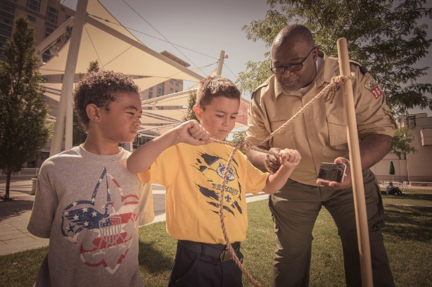
Pack dues of [AMOUNT] are collected in [TIME of COLLECTION]. We do our best to keep costs down. Yearly dues cover the following, plus many incidentals that allow the operation of the Pack. You can pay your Pack dues [METHOD OF PAYMENT]

Our Council and District
As you learn about Scouting you will hear about Council Events, District Events, and Pack Events. Below we give you an overview of what that means so that you have a better understanding of the structure.

Central Florida Council
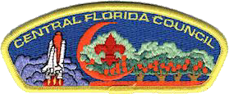
The Central Florida Council was formed in 1922 and serves Scouts in Orange, Osceola, Seminole, Lake, Brevard, Volusia, and Flagler Counties. The mission of Scouting America is to prepare young people to make ethical choices over their lifetimes by instilling in them the values of the Scout Oath and Law. Scouting has grown in meeting the needs of today's youth; teaching youth and adults to make value judgments and the importance of traditional values continues to make the Scouting program strong. The Council’s headquarters are in Apopka, Florida and its primary Scout camp is Camp La-No-Che, located adjacent to the Ocala National Forest in Lake County.

Lake District

The Council administers the Scouting program through 9 local districts. The Pack is a part of the Lake District. The District also provides volunteer support, training, program opportunities, events, fundraising opportunities, and administrative services at a more localized level. We may also attend District Events as a Pack.
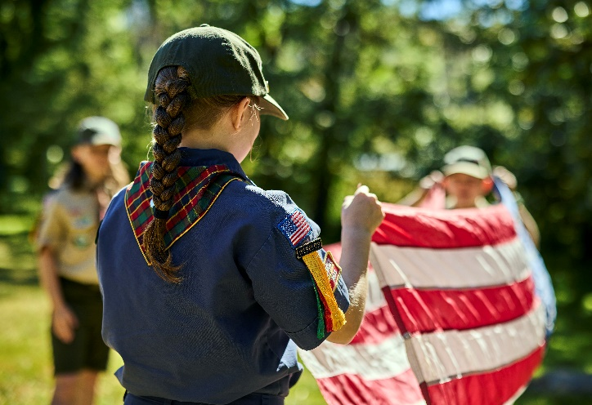
.
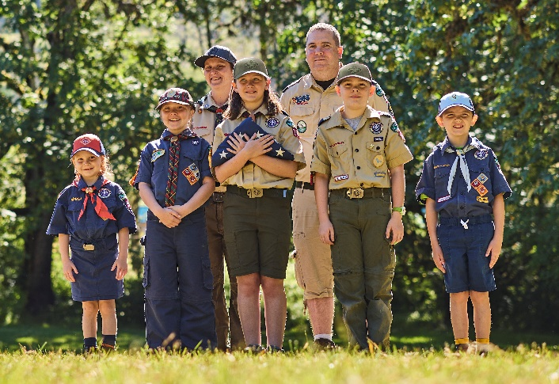

Pack Leadership

Adult Leadership
Scouting America at the Pack level is a completely volunteer-run organization. With your help, we can ensure our youth have a quality program full of learning, fun, and life-skills!
The success of the den and our pack depends on parental participation. Cub Scouting relies on volunteer leadership, which serves as an example of Scouting's principle of service to others. When you volunteer in Scouting, you are giving your child and family the gift of your time, which is incredibly valuable. Volunteering also allows you to be a positive influence in the lives of your child, their friends, and the community. Here are some ways you can volunteer:
Den leader: Uses the den meeting resources to lead the den at den meetings. Attends the monthly pack committee meeting.
Cubmaster: Helps plan and carry out the pack program with the help of the pack committee. Emcees the monthly pack meeting and attends the pack committee meeting.
Every Cub Scout parent or guardian is invited to become a member of the pack committee. Pack committee members perform administrative functions for our pack. The committee meets monthly and includes the responsibilities below.
Committee Chair: Presides at all pack committee meetings. Helps recruit adult leaders and attends the monthly pack meeting and pack committee meeting.
Advancement Chair: Maintains advancement records for our pack. Orders and obtains all badges and insignia. Attends the monthly pack meeting and pack committee meeting.
Secretary: Keeps records of the pack committee meetings and communicates with families about upcoming pack events and activities.
Treasurer: Keeps all financial records for our pack, including the pack bank account, and gives a monthly financial report to the pack committee. Attends the monthly pack meeting and pack committee meeting.
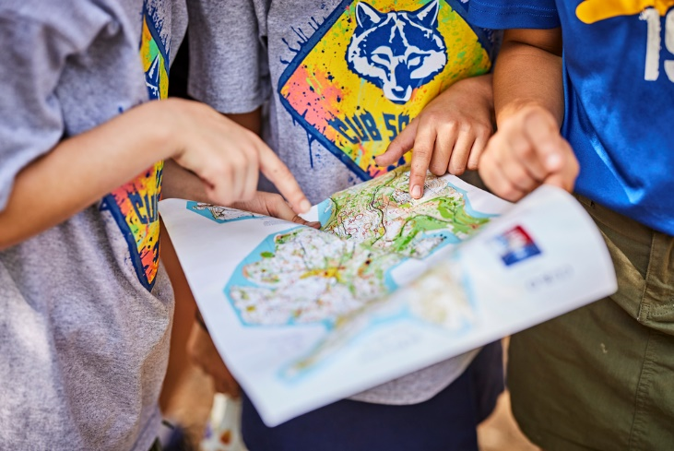
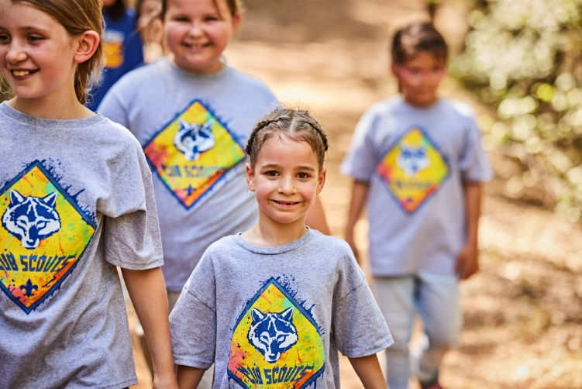
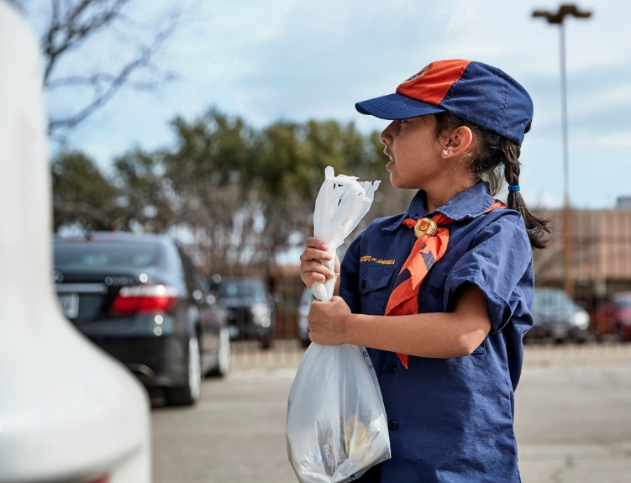
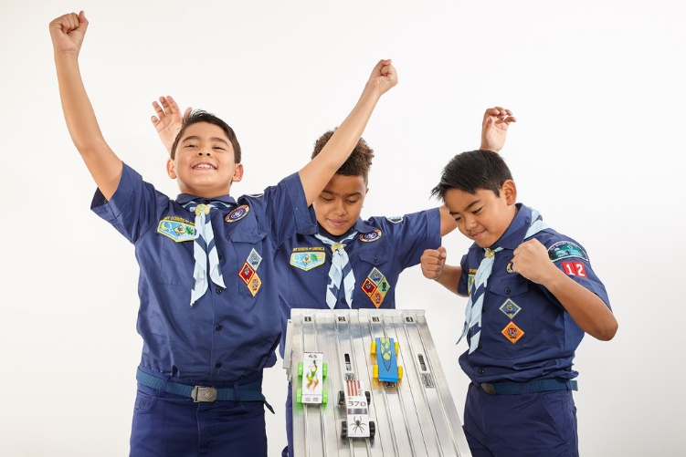
Below are the adult Cub Scout registered leadership positions we have in our Pack. In addition to these, many other Pack positions involve coordinating our numerous activities and events. There are various ways to get involved. Please speak to a current leader if you are willing to help!
Position | Volunteer
Chartered Organization
Chartered Organization Head
Chartered Organization Rep
Committee Chair
Committee Members
Treasurer
Cubmaster
Assistant Cubmaster
Lion Den Leader
Tiger Den Leader
Wolf Den Leader
Bear Den Leader
Webelos Leader
AOL Leader
Advancement Chair
Fundraising Chair
Fundraising Committee
Recruitment Chair
Blue and Gold Chair

Training
Scouting America offers convenient training for parents who volunteer. As a new parent, you can learn all about Cub Scouting and how quality Scouting programs are built. Log on to my.Scouting.org and create an account to gain access to all available training content. For more information about training at all levels of the program, go to www.scouting.org/ training
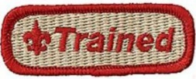
All adult leaders for positions in grey above must complete BSA’s Youth Protection & Position-specific training. Training can be completed online.
Child abuse is a serious problem in our society, and unfortunately, it can occur anywhere, even in Scouting. Youth safety is of paramount importance to Scouting. For that reason, Scouting America continues to create barriers to abuse beyond what has previously existed in Scouting.
Scouting America places the greatest importance on providing the most secure environment possible for its youth members. To maintain such an environment, Scouting America has developed numerous procedural and leadership selection policies and provides parents and leaders with multiple online and print resources for all Scouting programs.
All leaders are required to complete Youth Protection training. All parents are encouraged to take the training.
- To complete the training online, go to: https://training.scouting.org/learning-plans/1179
- Or on the homepage of my.scouting.org and establish an account using the member number you received when you registered for a Scouting America membership. If you take the training before you obtain a member number make sure to return to my.Scouting.org and enter your number for training record credit.
If a volunteer’s Youth Protection training record is not current at the time of recharter, the volunteer will not be registered. For more information about Youth Protection, please see Scouting America’s Youth Protection website at scouting.org/training/youth-protection.
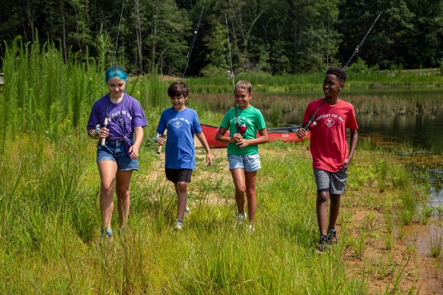
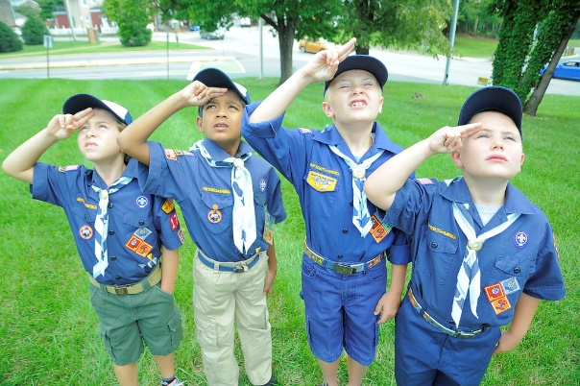

Uniforms
Cub Scouts, like any other team, have a uniform. These uniforms are an important part of Scouting and help to foster a sense of belonging, commitment, and equality. They also provide a way for Scouts to show off the achievements and awards they have earned.
There are two types of uniforms. The Field Uniform, also known as a “Class A” uniform is the more formal of the two and is normally worn to Troop meetings during the school year, for advancement-related events, and at other special events such as flag ceremonies. The other uniform is the Activity Uniform, also known as a “Class B” Pack t-shirt, that we wear to campouts, summer day camps, summer meetings, and work parties/projects. These t-shirts are available to adults as well and may be purchased from the [WHO] at [WHEN].
Cub Scouts has a couple of different uniforms depending on the Den:

Lions – Kindergarten
The Lion Cub Scout uniform has the following parts:
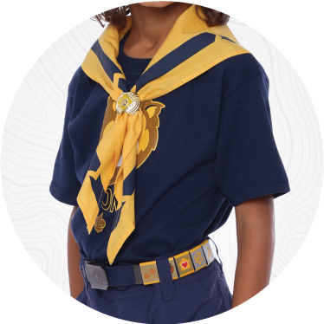
- Shirt: The official Lion t-shirt.
- Belt: Official navy-blue web belt with metal buckle.
- Cap: Official navy-blue lion cap.
- Neckerchief: Optional Lion neckerchief. The Lion Den decides if they will wear the neckerchief.
- Official uniform pants, shorts, or skorts, and Cub Scout socks are optional. The use of these items for Lions is decided by the den leader and families in the den.

Tiger- First Grade
The Tiger Cub Scout uniform has the following parts:
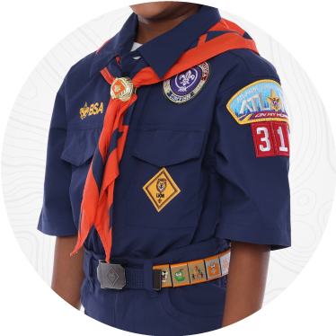
- Shirt: the official blue uniform shirt is available with long or short sleeves and has button-flap pockets.
- Pants: Shorts, long pants, skorts, and roll-up pants all are in official blue.
- Belt: Official navy-blue web belt with metal buckle.
- Socks: Official socks are available in three lengths: ankle, crew, and knee. Tiger Socks have an orange band on top.
- Hat: Official blue hat with orange front and tiger emblem.
- Neckerchief: Orange triangular neckerchief with Tiger logo. Official BSA neckerchiefs are the only neckerchiefs that are part of the uniform.
- Neckerchief slide: Official gold-tone metal slide with orange Tiger emblem. Cub Scouts may wear handmade neckerchief slides.

Wolf – Second Grade
The Wolf Cub Scout uniform has the following parts:
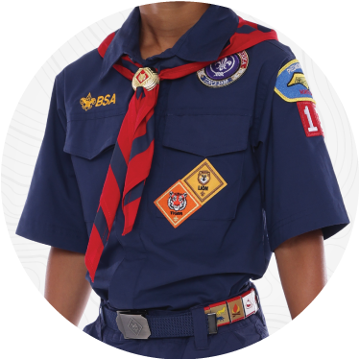
- Shirt: the official blue uniform shirt is available with long or short sleeves and has button-flap pockets.
- Pants: Shorts, long pants, skorts, and roll-up pants all are in official blue.
- Belt: Official navy-blue web belt with metal buckle.
- Socks: Official socks are available in three lengths: ankle, crew, and knee. Wolf Socks have a yellow band on top.
- Hat: Official blue hat with red front and wolf emblem.
- Neckerchief: Red triangular neckerchief with Wolf logo. Official BSA neckerchiefs are the only neckerchiefs that are part of the uniform.
- Neckerchief slide: Official gold-tone metal slide with red Wolf emblem. Cub Scouts may wear handmade neckerchief slides.

Bear – Third Grade
The Bear Cub Scout uniform has the following parts:
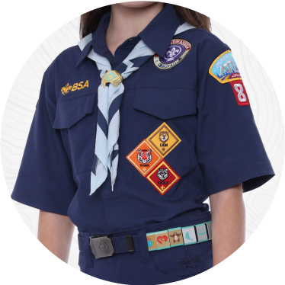
- Shirt: the official blue uniform shirt is available with long or short sleeves and has button-flap pockets.
- Pants: Shorts, long pants, skorts, and roll-up pants all are in official blue.
- Belt: Official navy-blue web belt with metal buckle.
- Socks: Official socks are available in three lengths: ankle, crew, and knee. Bear Socks have a yellow band on top.
- Hat: Official blue hat with light blue front and bear emblem.
- Neckerchief: Light-blue triangular neckerchief with bear logo. Official BSA neckerchiefs are the only neckerchiefs that are part of the uniform.
- Neckerchief slide: Official gold-tone metal slide with light-blue bear emblem. Cub Scouts may wear handmade neckerchief slides.

Webelos – Fourth Grade
The Webelos Cub Scout uniform has the following parts:
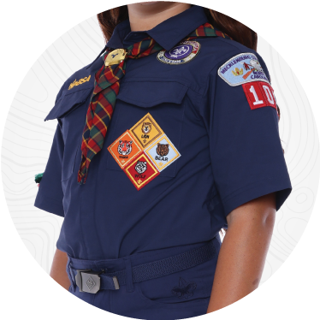
- Shirt: the official blue uniform shirt is available with long or short sleeves and has button-flap pockets.
- Pants: Shorts, long pants, skorts, and roll-up pants all are in official blue.
- Belt: Official navy-blue web belt with metal buckle.
- Socks: Official socks are available in three lengths: ankle, crew, and knee. Webelos Socks have a yellow band on top.
- Hat: Official green hat with Webelos plaid front and Webelos emblem.
- Neckerchief: Webelos plaid triangular neckerchief with Webelos logo.
- Neckerchief slide: Official gold-tone metal slide with Webelos emblem.
- Adventure Colors: The Adventure Colors are worn on the right sleeve to display the Webelos Adventure Pins that have been earned.

Arrow of Light – Fifth Grade
The Arrow of Light Cub Scout uniform has the following parts:
- Shirt: The official tan uniform shirt is available with long or short sleeves and has button-flap pockets.
- Pants: The official green shorts, long pants, skorts, and roll-up pants.
- Belt: Official green web belt with BSA buckle.
- Socks: Official green socks are available in three lengths: ankle, crew, and knee.
- Hat: Optional – Arrow of Light Scouts may wear any official BSA hat.
- Neckerchief: Optional – Arrow of Light Scouts may wear any official BSA neckerchief.
- Neckerchief slide: Official Scouts BSA slide with BSA emblem.
- Adventure Colors: The Adventure Colors are worn on the right sleeve to display the Arrow of Light Adventure Pins that have been earned.
- Loops: Official Cub Scouts blue loops are worn on the shoulders of the shirt.

If you get the uniform shirt on the larger side, it should last a few years. Check with friends and relatives, as they might have some previously experienced Scout uniforms tucked away in a closet. eBay is also a good resource for gently used uniform items.
Uniforms are available at the Scout Shop on 441 in Apopka; 1951 S Orange Blossom Trail Apopka, FL 32703; (407) 814-1040. The Scout Shop also sells pre-sewn uniforms & can sew on any patches that you might have.

Camping Checklist
If you are new to camping and a bit nervous or an experienced pro, that’s OK! Camping with Pack [NUMBER] allows you to camp while having other adults and Scouts around for advice and assistance! Each person must bring their own mess kit, silverware, and reusable water bottle.
If you don’t already have camping gear, there are extremely minimal requirements to get started! Below is a minimum suggested list of items. All are available at Academy, Coleman.com, Dicks, the Scout Store, Walmart, Amazon, etc. Subscribe to the sale lists of several of these and you’ll be amazed at the deals you can find!

✓ | Item | Comment | Cost
 | Tent | Scouts and adults camp in their personal tent. Many prefer 3-person tents. | $35-  $125
 | Tarp(s) | A tarp to put under your tent to keep clean & dry. Can also be used in an emergency to fix a leaking tent! | $0 -  $10
 | Sleeping Pad | Much more comfortable than sleeping on the ground! Smaller Klymit or similar ones that can shrink down into a pack. | $30 -  $45
 | Backpack | A soft side bag will work, but a dedicated camping backpack  makes life easy, as you don’t have to pack each trip! 40-64L | $27-  $37
 | Sleeping bag | Sleeping bags are great, but sometimes you can take sheets & a blanket.  NOTE: 30 degree bag will keep you warm down to 50 degrees | $25+
 | Camping chair | Search Amazon for lightweight camping chairs that can be easily carried and broken down and carried. | $20-  $30
 | Towel | Swimming, showering, etc. Amazon has microfiber towels that dry quickly while camping, or from the closet at home. | $0-$15
 | Mess Kit & Silverware | Required to eat, as the Pack does not supply plates & plastic utensils. Walmart, Amazon, or the Scout Store. | $6-$20
 | Flashlight/ Headlamp | Don’t forget to pack extra batteries. | $1-$20
 |  | Additional items to bring
 | USB battery pack | There aren’t always a lot of plugs available. These allow you to keep your phone charged. ADULTS ONLY | $10-  $30
 | Pillow | Regular or camping | $0-$15
 | Water bottle | Required for hydration
 | Sunscreen
 | Bug repellent
 | Knife | No larger than a Scout's palm. Only if they have Wittln’s Chit.
 | Toiletries
 | Changes of clothes | Weather dependent, but don’t forget bathing suits, rain ponchos, jackets, etc. depending on the activity. It is often colder camping than it is in town.

Pack [NUMBER] Camping Policy

[Placeholder for Pack Camping Policies things like close-toed shoes or no electronics]

The Pack realizes that there will be occasional exceptions to the policies above; specifically in cases of earlier camping reservation dates, traffic delays, cases of COVID, etc. We encourage you to email our [LEADER ROLE] with any potential exceptions.

